**02. Geoprocessing — Daily Cycling Routes**

**1. Introduction**

Cycling is my primary mode of transport in New York City. These routes represent my daily and weekend journeys, mapped to reflect my lived navigation patterns. By analysing them alongside NYC’s official bike route dataset, I can assess route safety, infrastructure coverage, and possible optimisations.

**2. Dataset 1 — My Daily Cycling Routes**

**File:** daily and weekly_cycle_routes.geojson.geojson  
**Description:** Three personal cycle routes traced manually in [geojson.io](https://geojson.io) based on real travel patterns:

1. **House to Columbia University** – Daily commute to campus.
2. **House to Trader Joe’s** – Grocery shopping route.
3. **House to South Ferry via Riverside Pathway** – Weekend leisure ride.

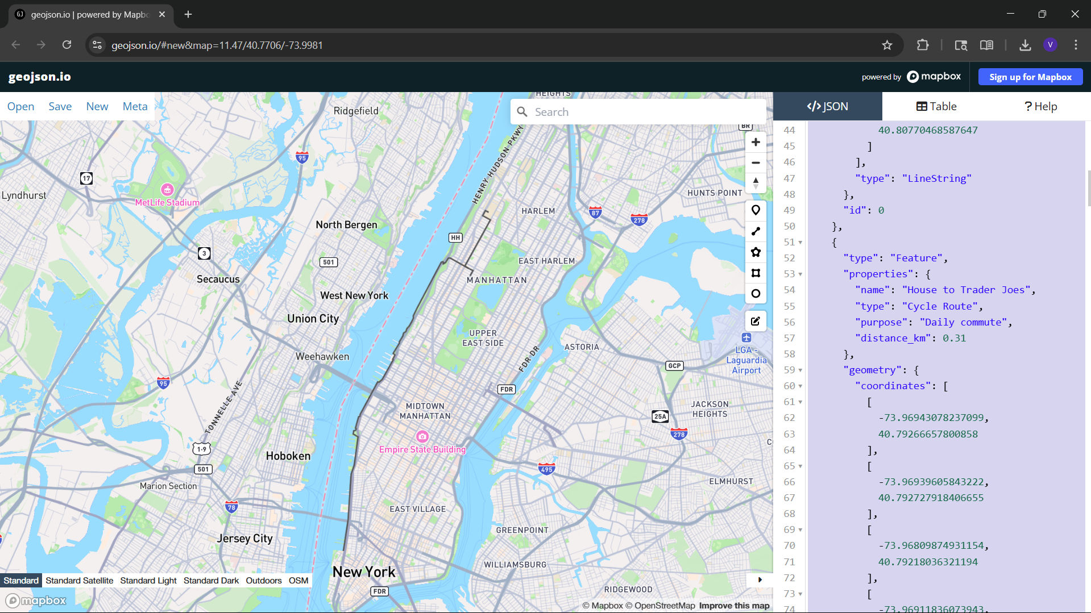

**3. Dataset 2 — Related Dataset**

**Source:** [NYC Open Data — Bike Routes](https://data.cityofnewyork.us/Transportation/Bike-Routes/7vsa-caz7)  
**Description:** The official New York City bike route network dataset, detailing protected lanes, shared lanes, and greenways across the five boroughs. This dataset provides a reference for assessing how closely my personal routes align with existing infrastructure.

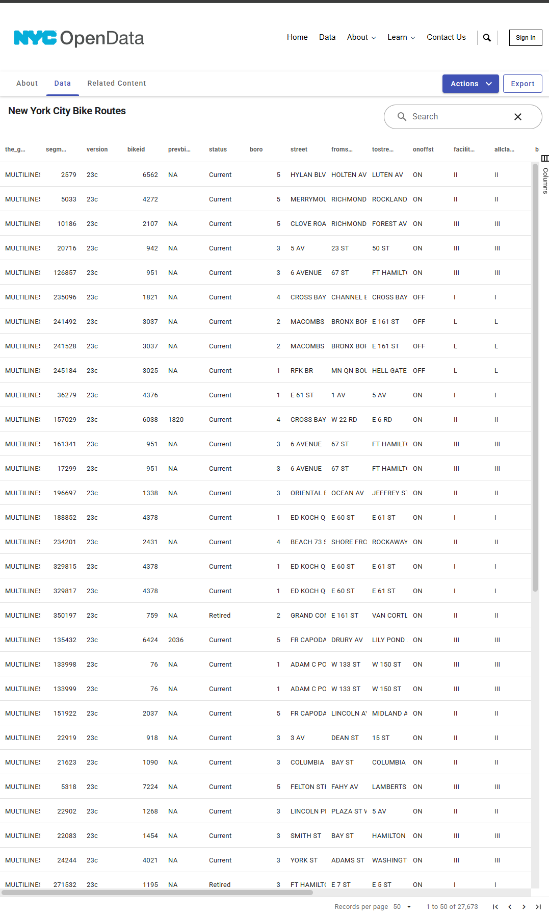

**4. Proposed Workflow**

1. Import **daily_cycle_routes.geojson** into QGIS.
2. Import the **NYC Bike Routes** dataset from NYC Open Data.
3. Overlay personal routes on the official bike route layer.
4. Classify route segments into:
   * **Protected lanes**
   * **Shared lanes**
   * **Unprotected segments**
5. Identify high-risk segments and explore potential safer alternatives.

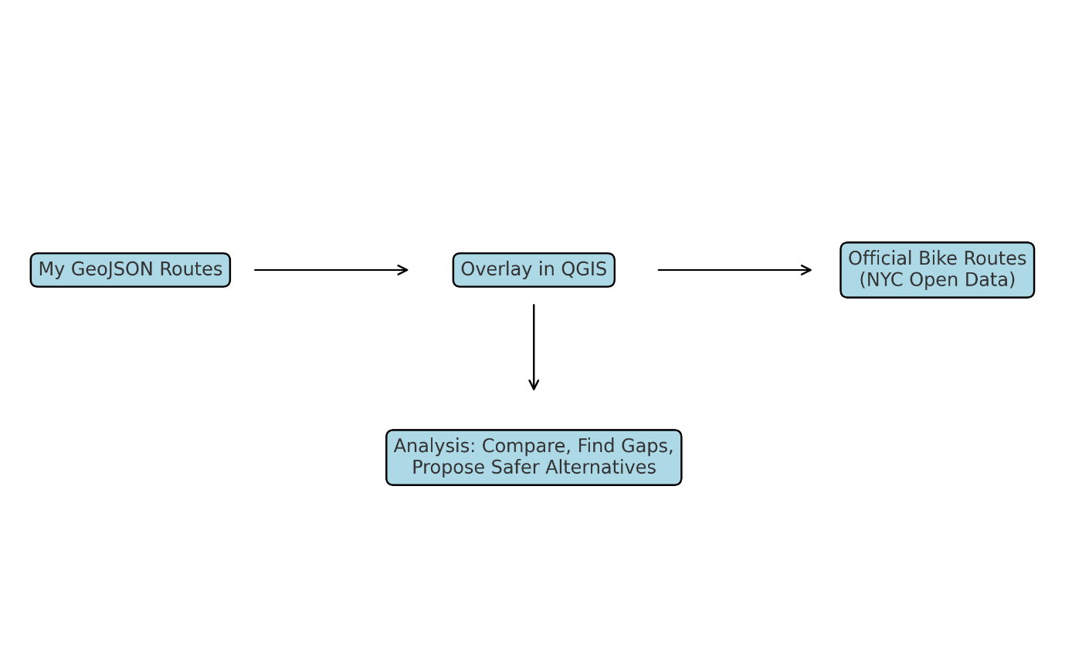

**5. Expected Outcomes**

* Identify the percentage of my cycling distance spent on official bike lanes.
* Highlight infrastructure gaps on my daily commute.
* Propose route modifications for improved safety and efficiency.
* Potentially advocate for new protected lanes in under-served areas.